Money Module

Class Diagram

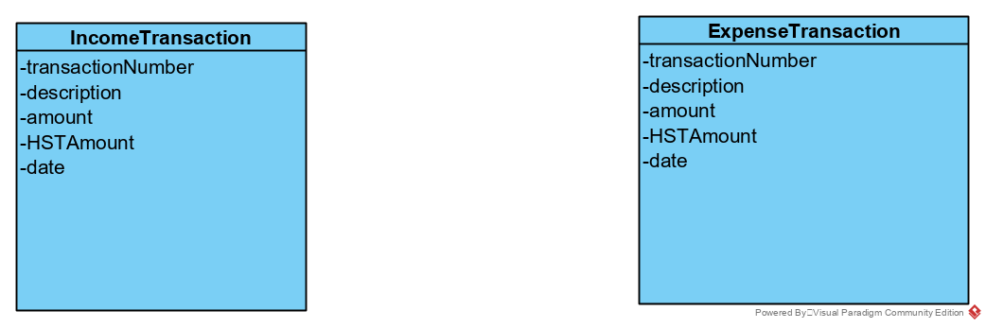

Create an income transaction

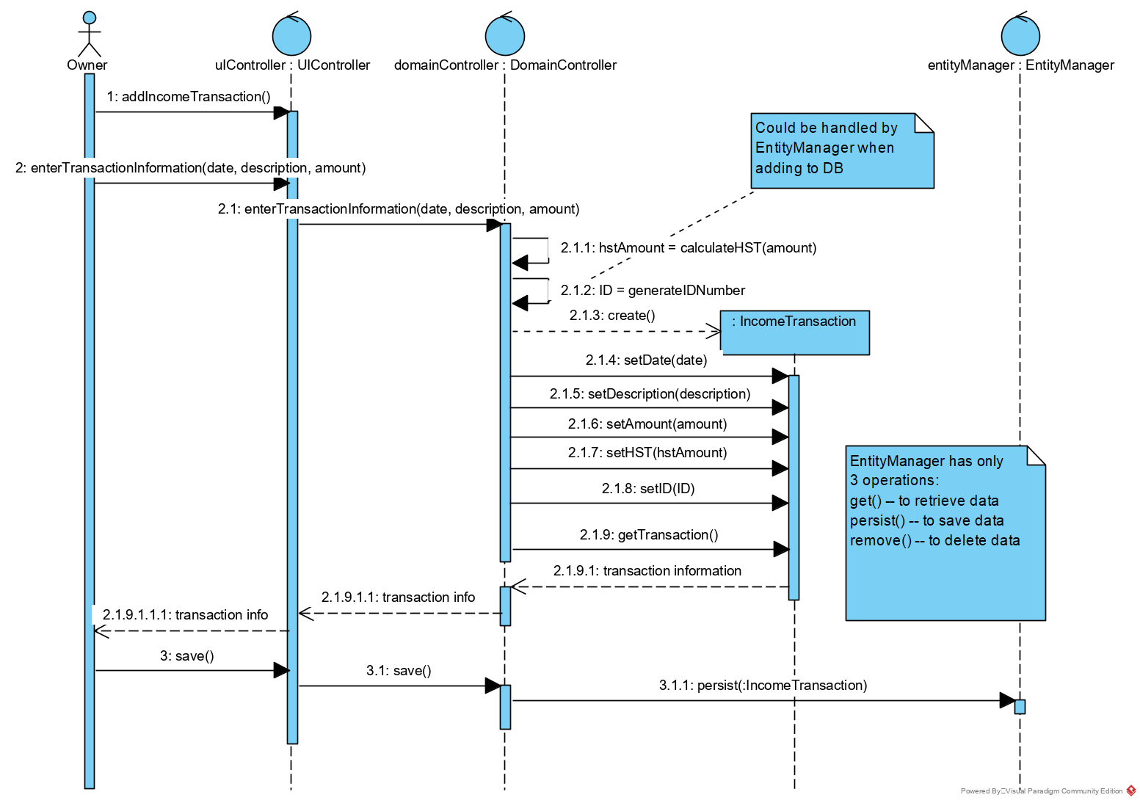

Create an expense transaction

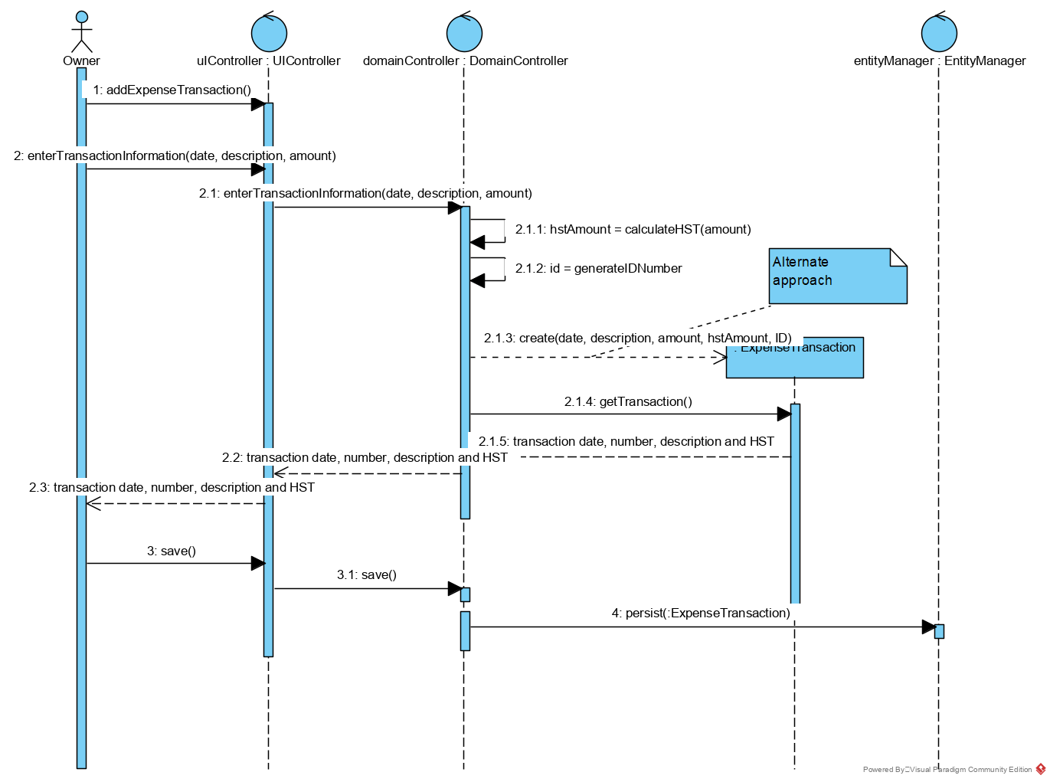

Query Financial Transactions

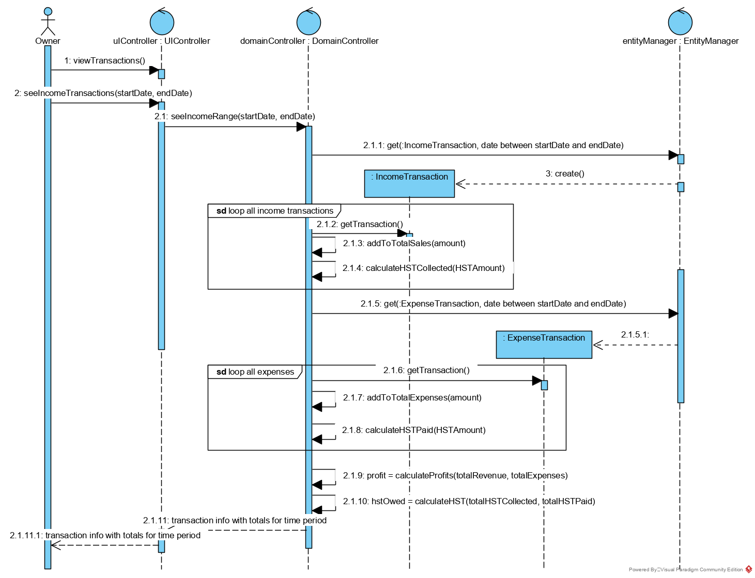

.h files

IncomeTransaction.h

public class IncomeTransaction {

int transactionNumber;

String description;

float amount;

float HSTAmount;

int date;

create()

// creates an income transaction

setDate(date)

// updates the date

setDescription(description)

// updates the description

setAmount(amount)

// updates the amount

setHST(hstAmount)

// updates the hst amount

setID(ID)

// updates the ID

getTransaction()

// returns the transaction

}

ExpenseTransaction.h

public class ExpenseTransaction {

int transactionNumber;

String description;

float amount;

float HSTAmount;

int date;

create(date,description, amount, hastAmount, ID)

// creates an expense transaction

getTransaction()

// gets expense transaction

}

UIController.h

public class UIController {

addIncomeTransaction()

// displays a form, prompting for an income transaction

addExpenseTransaction()

// displays a form, prompting for an expense transaction

enterIncomeTransaction(date,description,amount)

// passes income Transaction data to the domain controller class

// returns income transaction data to the user

enterTransactionInformation(date,description,amount)

// passes expense Transaction data to the domain controller class

// returns expense transaction data to the user

viewTransactions()

// displays a calender

seeIncomeTransactions(startDate, endDate)

// sends request to domain controller class to retrieve transactions within a specified date

save()

// starts request to save data

}

DomainController.h

public class DomainController {

enterTransactionInformation(date,description, amount)

// receives transaction information

float calculateHST(amount)

// returns the HST value

int generateIDNumber()

// generates a unique ID number

save()

// saves data

seeIncomeRange(startDate, endDate)

// sends requests to retrieve transactions

float addToSale(amount)

// updates total sales

float calculateHSTCollected(HSTAmount)

// updates total calculated HST

float AddToTotalExpenses(amount)

// updates total expenses

float calculateHSTPaid(HSTAmount)

// updates HST paid

float calculateProfits(totalRevenue,totalExpense

// profit = revenue – expense

float calculateHST(totalHSTCollected, totalHSTPaid)

// owed = collected - paid

}

EntityManager.h

public class EntityManager {

persist(object)

// saves

get(class, selection criteria)

// retrieves from the table

}